**Devansh Shah**

**1914078**

**B2**

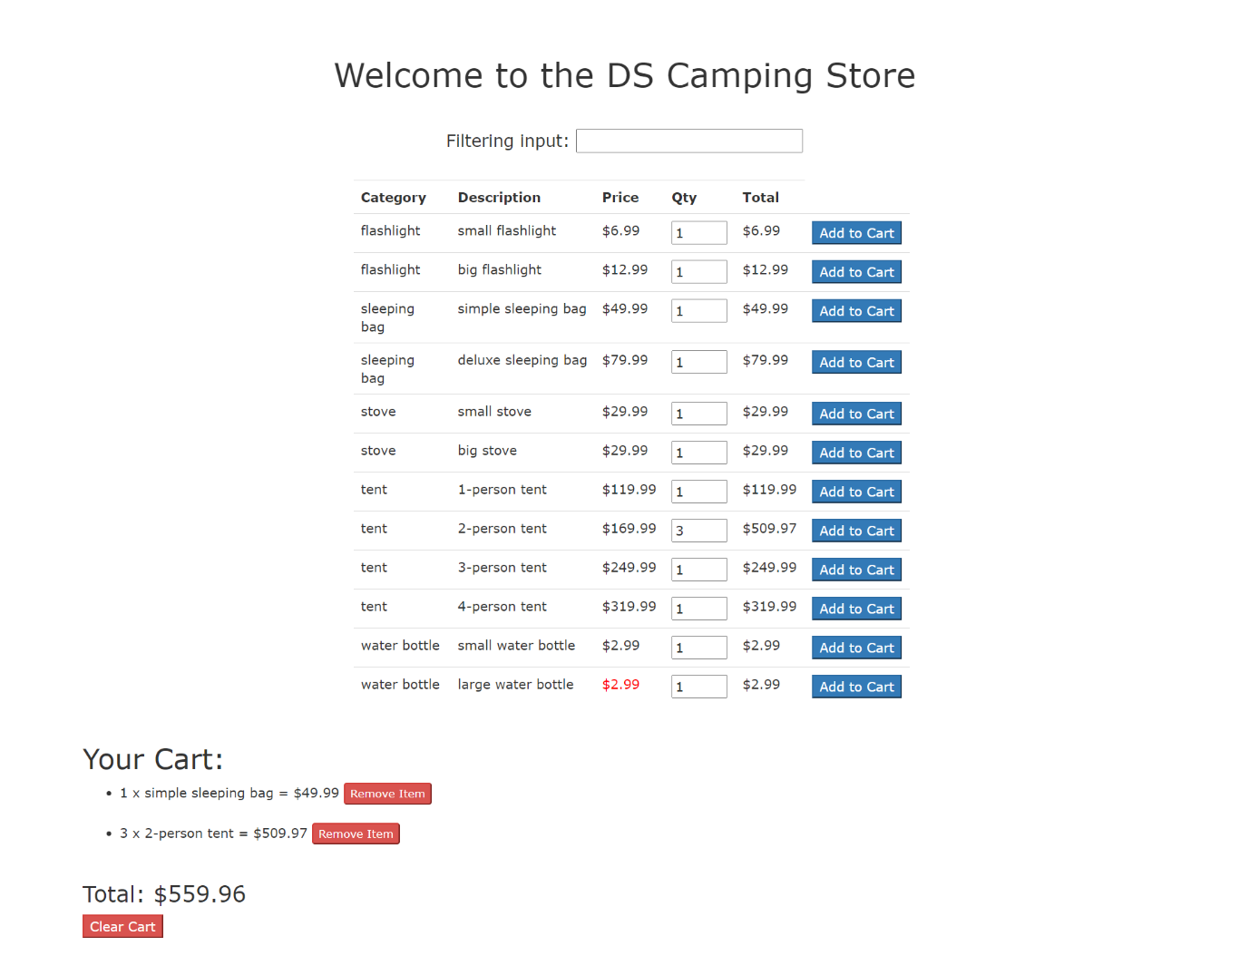

Technology used : AngularJS, Json, Html, Css

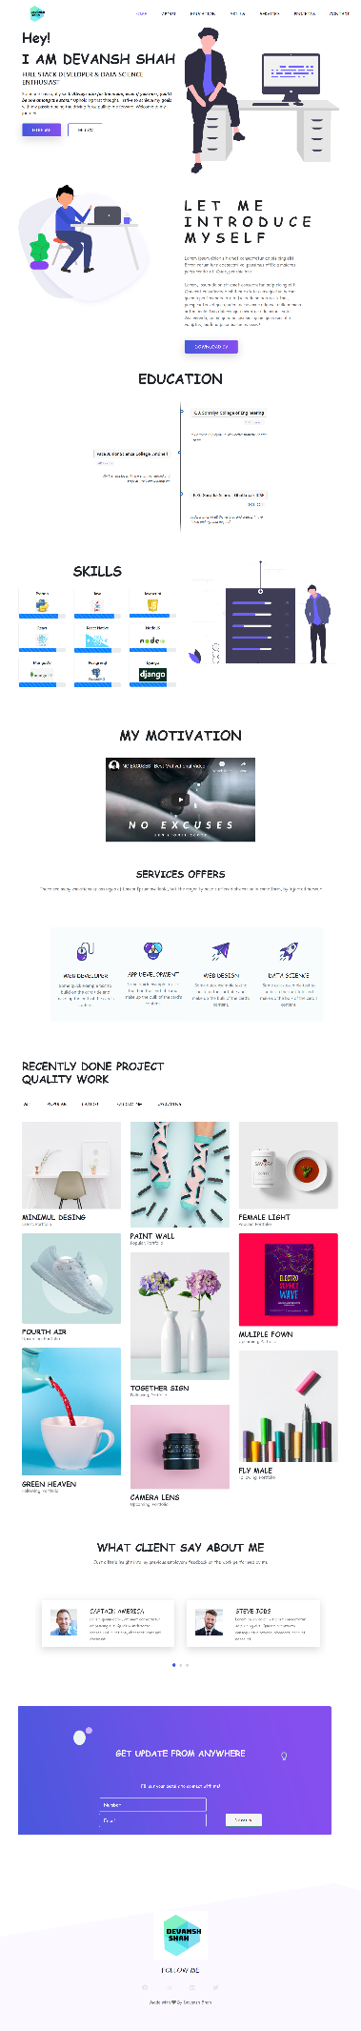 Portfolio Website

Preloader

Technnology used: Html5, css3, javascript, jquery, bootstrap, owl carousel js, magnificent pop up js, isotope js

Conclusion:

This mini project helped me build myself a profile website which will in turn help me make a larger online presence. I got a chance to brush up my web development skills and learnt to use many new libraries and frameworks like angular and using them create advanced features for my site.